EGR326 PreLab 9

Control of a stepper motor

A stepper motor provides an embedded system with a means of fairly precise control of rotational movement at reasonable cost. In your design project you have a requirement to control a stepper motor to operate a speedometer. The bipolar stepper motor provided in your lab/project kit is driven by the L293 control board which interfaces to the GPIO pins on the STM32F446

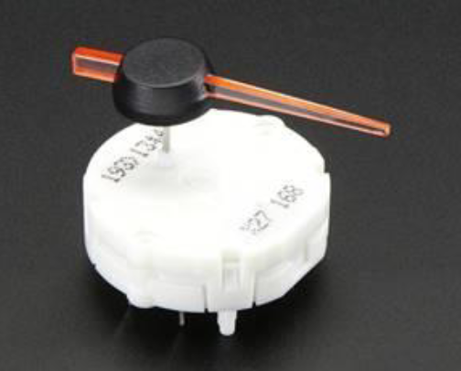

* Draw a schematic of a complete circuit, from the MSP432, through the motor control board to the stepper motor.
* Document the sequence in which you will step the signals to the motor over GPIO (both directions)
* Draw a schematic connecting two STM32F446 via the I2C communication modules.
* Download the lab 9 exercise document and study the deliverables. Come to lab prepared to show your full step control sequence of the stepper motor used in part I of the lab.
* You may have to solder connections to your motor- as the leads don’t fit snuggly in standard wire sockets.